**Solar PV Induction Cooktop**

**Aim:** the aim of this project is to develop an induction cooktop which can run on low power (300 W) solar panel as well on our regular household supply.

**Description:** The induction cooktop works on oscillation of energy between the coil and capacitor (LC tank circuit). The frequency of oscillation is determined by the relation

***f*** = 1 / ( 2π * √[**L** * **C]**).

1) Zero Voltage Switching: this circuit is used for in case the supply voltage is less than 50-60 V.

The circuit diagram of the ZVS is given in the following link <http://www.kiblerelectronics.com/bob/app_notes/note11/note11.html>

Upon application of power, current flows through both sides of the MOSFET’s drains. One of the MOSFETs turns on faster than the other and more current draws to this MOSFET. This causes the other MOSFET to be turn off. The voltage starts to rise and fall sinusoidally. When Q1 turns on, the voltage at drain of Q1 will be ground while voltage at source of Q2 rises to a peak and drops back down during the one half cycle of LC tank. As voltage of the source of Q2 drops to zero, the gate current to Q1 is also removed and as a result, Q1 turns off. This causes the drain voltage of Q1 to rise and Q2 turns on. The MOSFETs switch when there is least power induced. The same process repeats for the second half cycle. To prevent the oscillator from drawing huge peak currents and explodes, L1 is placed in series with the power supply functioning as a choke to mitigate current spikes. R1 limits the current that charges the gates to avoid damage of over current at the MOSFET. R3 of 10k pulls the voltage down to ground to avoid latchup. The Zener diodes regulates the voltage at 18 V. D1 and D2 ensures the gates voltage down to ground when the voltage on the opposite leg of the tanks is at ground.

Some links about ZVS: <https://adammunich.com/zvs-driver/>

<https://teslascience.wordpress.com/how-to-make-a-solar-powered-induction-cooktop/>

2) Current induction cooktop: the cooktop which is there is the lab for analysis has one IGBT which is driven by transistor gate driver circuit. The circuit diagram of this cooktop is,

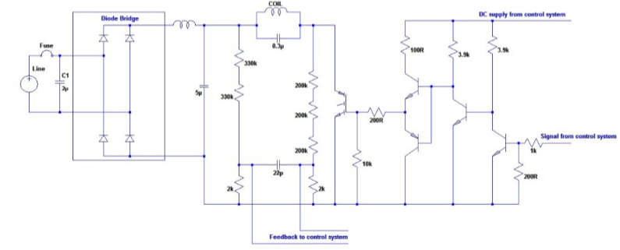

In this the AC supply is sent directly to rectifier where the rectified out is applied directly to the LC resonant circuit. The rectified supply is also step down using SMPS so as to provide low voltage DC to microcontroller and fan.

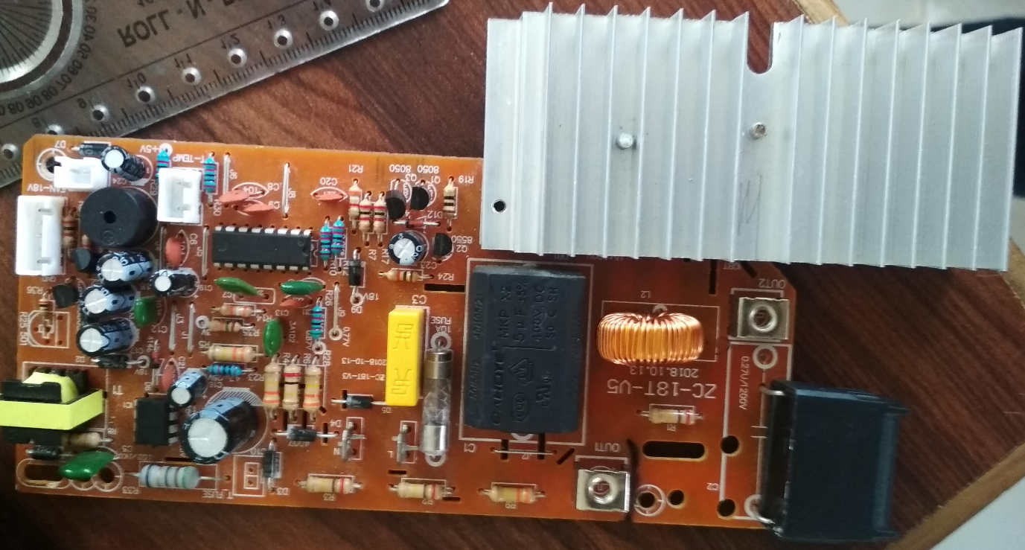

**OUR APPROACH:**

Since our cooktop has to work on both- low voltage as well as high voltage (around 311V) so we had used full bridge configuration which has 4 IGBT.

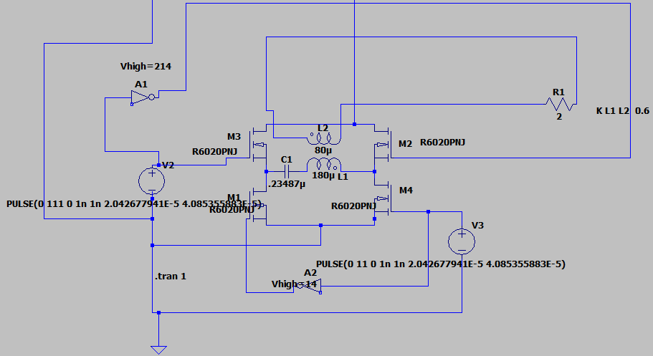

In this at one instant M3 and M4 is started and in the next M2 and M1 is started. The gate is drive by using gate driver IC IR2110. We had used series resonant circuit as it gives sustain sinusoidal oscillation. The value of inductor and resistor of coil is found to be 180uH and 2 ohm respectively. We found out that parallel resonant circuit is also possible but for that both (capacitor and inductor) should have the same time constant for sustain oscillation or there should be an LCR circuit.

Apart from that it is found that the oscillation is best when the frequency of oscillation of LC circuit and PWM frequency is exactly same. The maximum power occurs when the duty cycle of PWM is 50%. The power on either side of 50% duty cycle decreases. It must be note that the LC resonant frequency changes when the utensil is placed on it. So accordingly one has to change the PWM frequency.

Refer the below documentation to get more information about frequency of PWM and induction

<https://www.st.com/content/ccc/resource/technical/document/application_note/85/d9/5e/8f/23/24/4b/56/CD00115561.pdf/files/CD00115561.pdf/jcr:content/translations/en.CD00115561.pdf>

The voltage and current spikes can be reduced using voltage suppression diode and inductor. It has to be ensure that switching of the IGBT should occur when the voltage of LC oscillation changes from positive cycle to negative cycle and vice versa. So a ZVS circuit should be included (using optocoupler) so that whenever the voltage wave crosses zero it gives a signal (interrupt) to microcontroller which on receiving that signal generates PWM signal accordingly.

It is found that when no utensils is kept on coil the current and power developed is to high so it is always advisable to place utensils before starting the induction. In the above circuit the 80uH inductor and 2 ohm resistor is behaving as a utensil. It must be notice that effective coupling coefficient must be taken as the coefficient value directly indicates the amount of energy transfer from coil to utensil.

The relation to calculate the inductance of the spiral coil

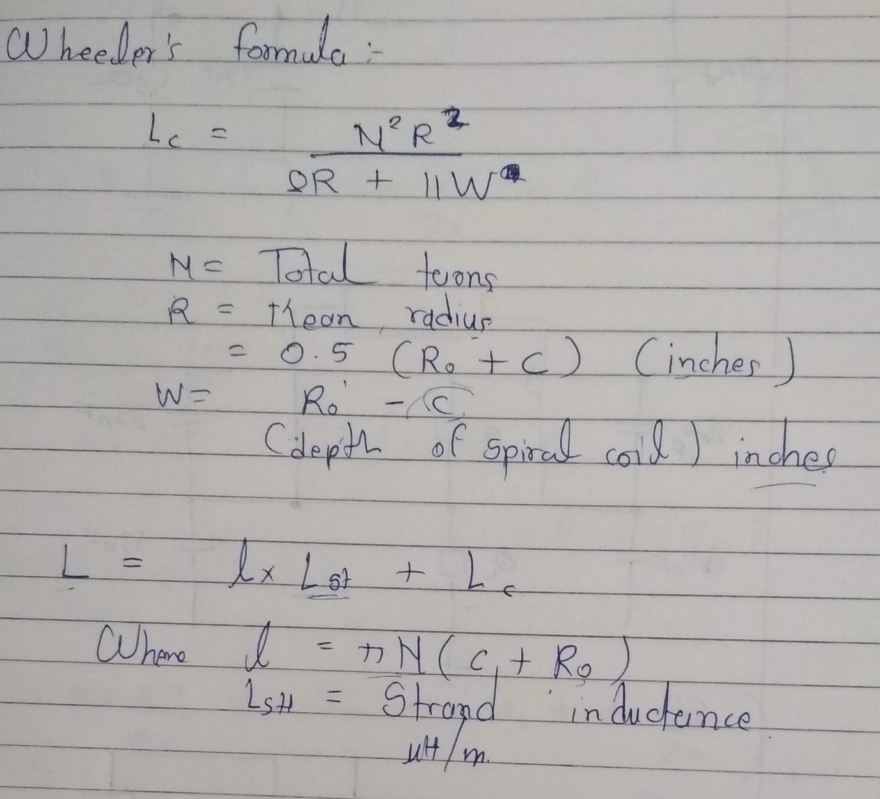

**The drive link of all the files is given in the below link:**

<https://drive.google.com/drive/folders/1erjLLt3BaIRb5FpDtMRSphMDFtcMAYM2?usp=sharing>

Some links regarding the gate driver IC IR2110:

1) <http://tahmidmc.blogspot.com/2013/01/using-high-low-side-driver-ir2110-with.html>

2) <https://krakkus.com/ir2110-mosfet-driver-quickstart-guide/>

The IGBT circuit: it is equipped with 20A fuse and a voltage suppression diode, its better to place an inductor so as to reduce current spikes

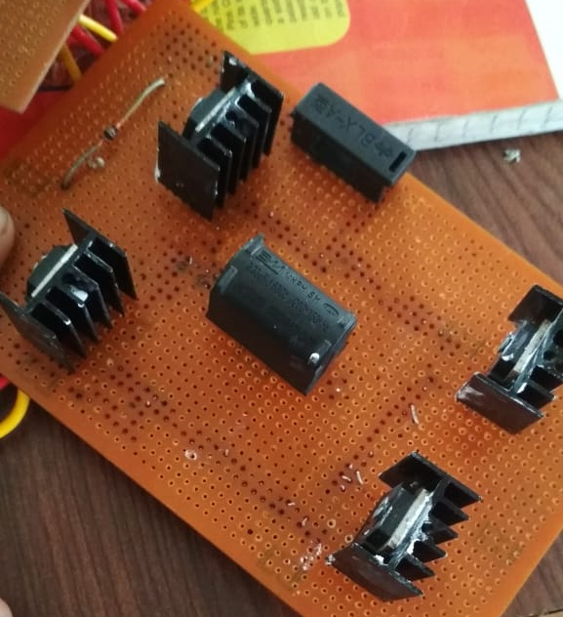

The gate driver circuit: It is drawn in accordance with the proteus driver circuit design

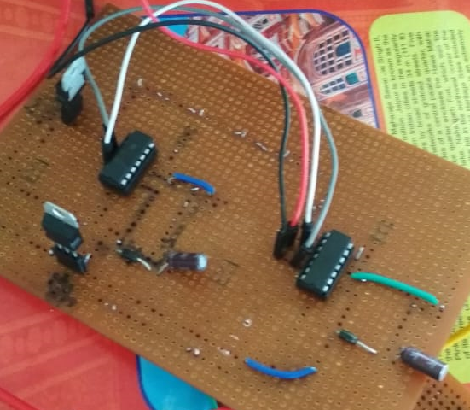

Combined circuit: the terminals from IC is connected to gate terminals and source. Opposite terminals is connected so as to provide same signal and the other is provided with inverted signal using 7804 NOT gate IC.

